**Action Methods In Asp.Net Mvc**

A controller class can contains one or more action methods, also known as controller actions.

**CONTROLLER**

* Manages the flow of the application.
* Is responsible for intercepting incoming requests and executing the appropriate application code.
* Communicates with the models of the application and selects the required view to be rendered for the request.
* Get data from database and specify a view that returns a response to the client.
* These tasks are done by Controller’s Action methods.

**Action methods:**

* Action methods are public methods in Controller classes.
* Are responsible for processing the requests that are sent to the controller.
* Typically returns an ActionResult object that encapsulates the result of executing the method.
* By Default, it generates a response in the form of **ActionResult**.

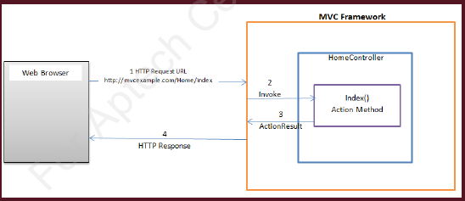

The steps in the preceding figure are as follows:

* The browser sends an HTTP request.
* The MVC Framework invokes the controller action method based on the request URL.
* The action method executes and returns an **ActionResult** object. This object encapsulates the result of the action method execution.
* The MVC Framework converts an ActionResult to HTTP response and sends the response back to the browser.

**Rules that you need to consider while creating an action method are as follows:**

* They must be declared as **public**.
* Action method must be **public**. It cannot be **private** or **protected**.
* They cannot be declared as **static**.
* They cannot have **overloaded** versions based on parameters.

**Invoking Action Methods**

* In an ASP.NET MVC application, you can create multiple action methods in a controller.
* You can invoke an action method by specifying a URL in the Web browser containing the name of the controller and the action method to invoke.

**ActionResult:**

* Is an abstract base class for all implementing classes that provides different types of results.
* Consists of HTML in combination with server-side and client-side scripts to respond to user actions.

Following table shows the commonly used classes that extend the ActionResult class to provide different implementations of the results of an action method:

